**Aim: To Implement the following Data structures in Java**

**a)Linked Lists b) Stacks c) Queues d) Set e) Map**

1. **LINKED LIST**

**Program**:

import java.util.*;

public class LinkedListDemo

{

public static void main(String args[])

{

// create a linked list

LinkedList ll = new LinkedList();

//add elements to the linked list

ll.add("F");

ll.add("B");

ll.add("D");

ll.add("E");

ll.add("C");

ll.addLast("Z");

ll.addFirst("A");

ll.add(1, "A2");

System.out.println("Original contents of ll: " + ll);

//remove elements from the linked list

ll.remove("F");

ll.remove(2);

System.out.println("Contents of ll after deletion: " + ll);

//remove first and last elements

ll.removeFirst();

ll.removeLast();

System.out.println("ll after deleting first and last: "+ ll);

//get and set a value

Object val = ll.get(2);

ll.set(2, (String) val + " Changed");

System.out.println("ll after change: " + ll);

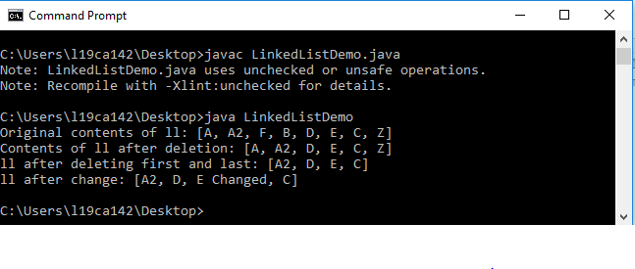

**b. STACK**

**Program:**

import java.util.*;

public class StackDemo {

static void showpush(Stack st, int a) {

st.push(new Integer(a));

System.out.println("push(" + a + ")");

System.out.println("stack: " + st);

}

static void showpop(Stack st) {

System.out.print("pop -> ");

Integer a = (Integer) st.pop();

System.out.println(a);

System.out.println("stack: " + st);

}

public static void main(String args[]) {

Stack st = new Stack();

System.out.println("stack: " + st);

showpush(st, 42);

showpush(st, 66);

showpush(st, 99);

showpop(st);

showpop(st);

showpop(st);

try {

showpop(st);

}catch (EmptyStackException e) {

System.out.println("empty stack");

}

}

}

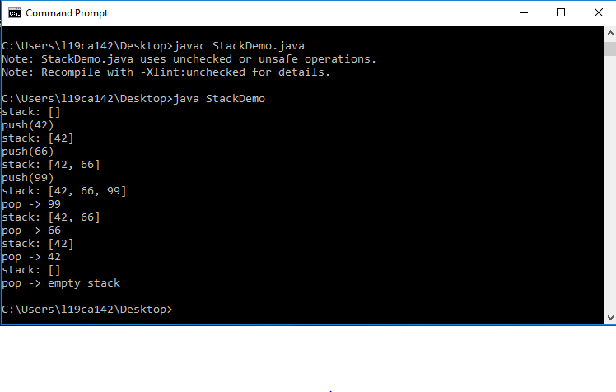

**c QUEUE**

**Program:**

import java.util.*;

public class QueueExample

{

public static void main(String[] args)

{

Queue<Integer> q = new LinkedList<>();

//Adds elements {0, 1, 2, 3, 4} to queue

for (int i=0; i<5; i++)

q.add(i);

//Display contents of the queue.

System.out.println("Elements of queue-"+q);

//To remove the head of queue.

int removedele = q.remove();

System.out.println("removed element-" + removedele);

System.out.println(q);

//To view the head of queue

int head = q.peek();

System.out.println("head of the queue-"+head);

//Rest all methods of collection interface,

//Like size and contains can be used with thisimplementation.

int size = q.size();

System.out.println("Size of queue-" + size);

}

}

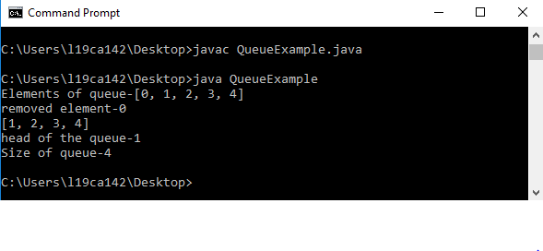

**d. SET**

**Program:**

import java.util.*;

public class SetDemo {

public static void main(String args[]) {

int count[] = {34, 22,10,60,30,22};

Set<Integer> set = new HashSet<Integer>();

try{

for(int i = 0; i<5; i++){

set.add(count[i]);

}

System.out.println(set);

TreeSet sortedSet = new TreeSet<Integer>(set);

System.out.println("The sorted list is:");

System.out.println(sortedSet);

System.out.println("The First element of the set is: "+(Integer)sortedSet.first());

System.out.println("The last element of the set is: "+(Integer)sortedSet.last());

}

catch(Exception e){}

}

}

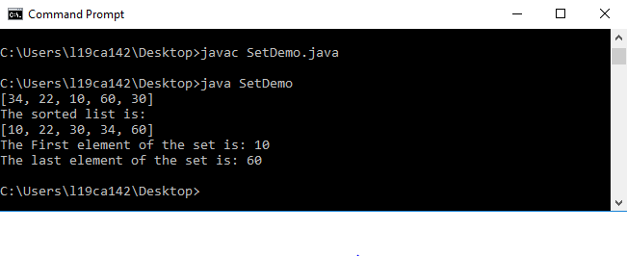

**e MAP**

**Program:**

import java.awt.Color;

import java.util.HashMap;

import java.util.Map;

import java.util.Set;

public class MapDemo

{

public static void main(String[] args)

{

Map<String, Color> favoriteColors = new HashMap<String, Color>();

favoriteColors.put("sai", Color.BLUE);

favoriteColors.put("Ram", Color.GREEN);

favoriteColors.put("krishna", Color.RED);

favoriteColors.put("narayana", Color.BLUE);

// Print all keys and values in the map

Set<String> keySet = favoriteColors.keySet();

for (String key : keySet)

{

Color value = favoriteColors.get(key);

System.out.println(key + " : " + value);

}

}

}

